Create the following table structure in SNOWFLAKE by creating your own warehouse. Insert some 10 rows using INSERT command (check task 3 and same way insert for all task tables) in the table by trying different values for all the columns and then check using SELECT *

Once data is loaded, performed the below task

**Task 1:**

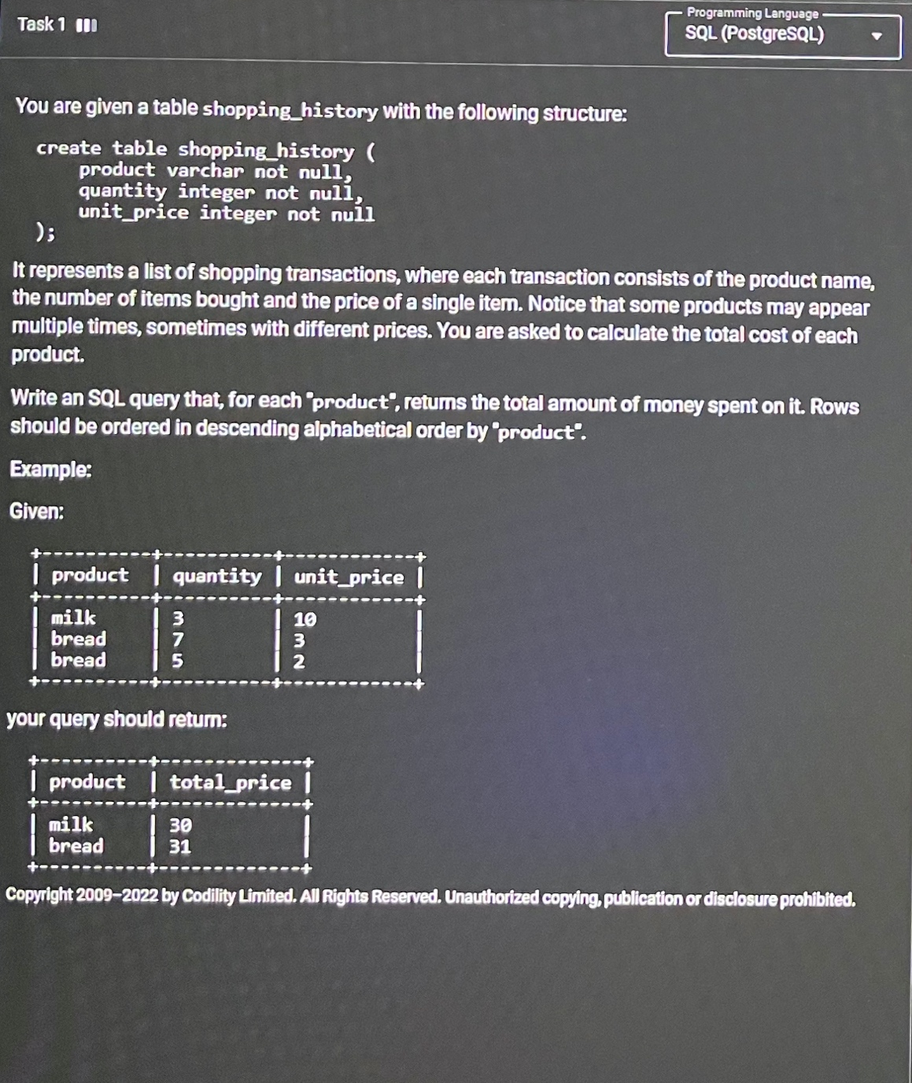

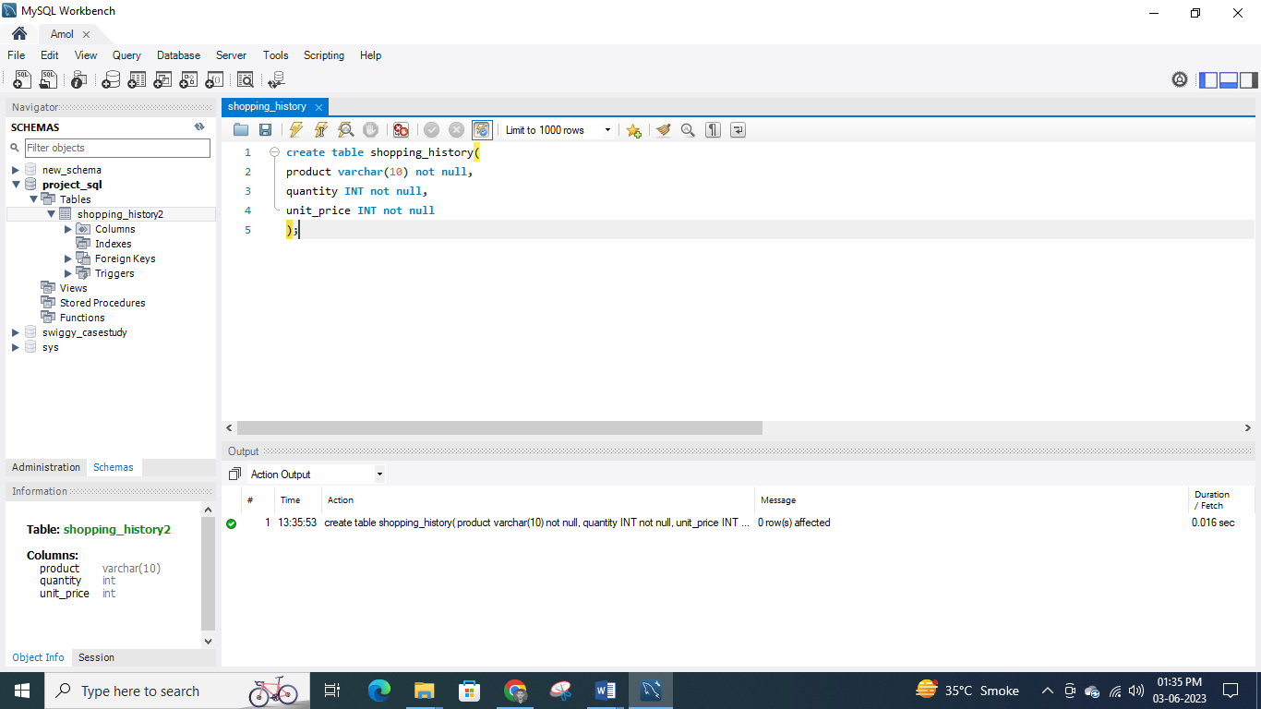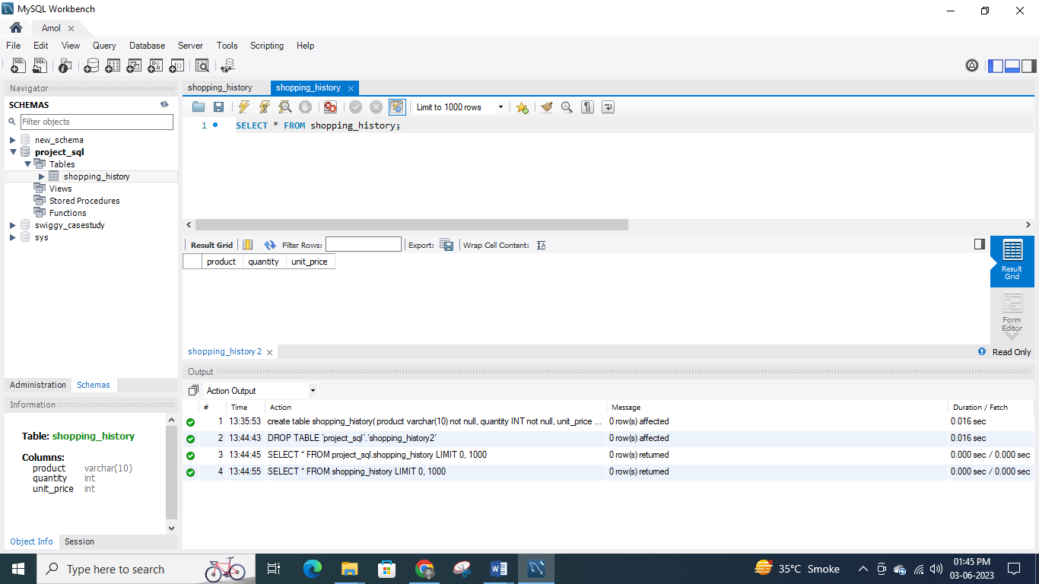 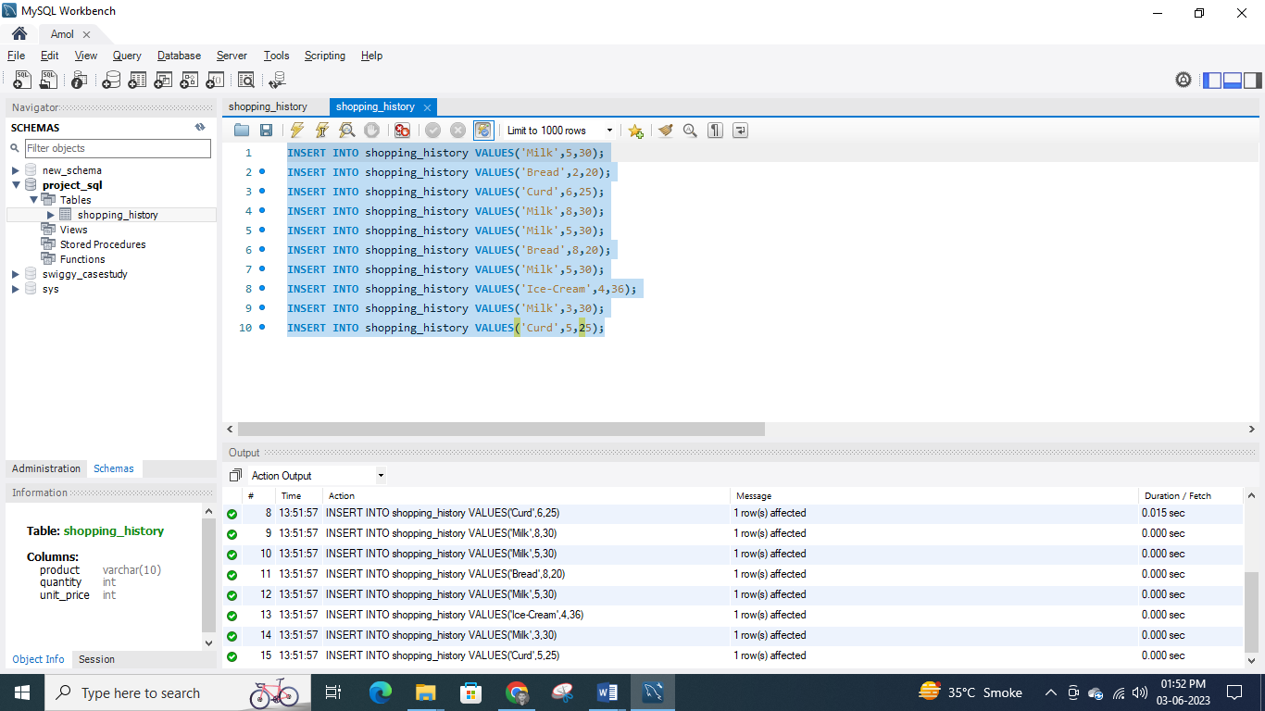 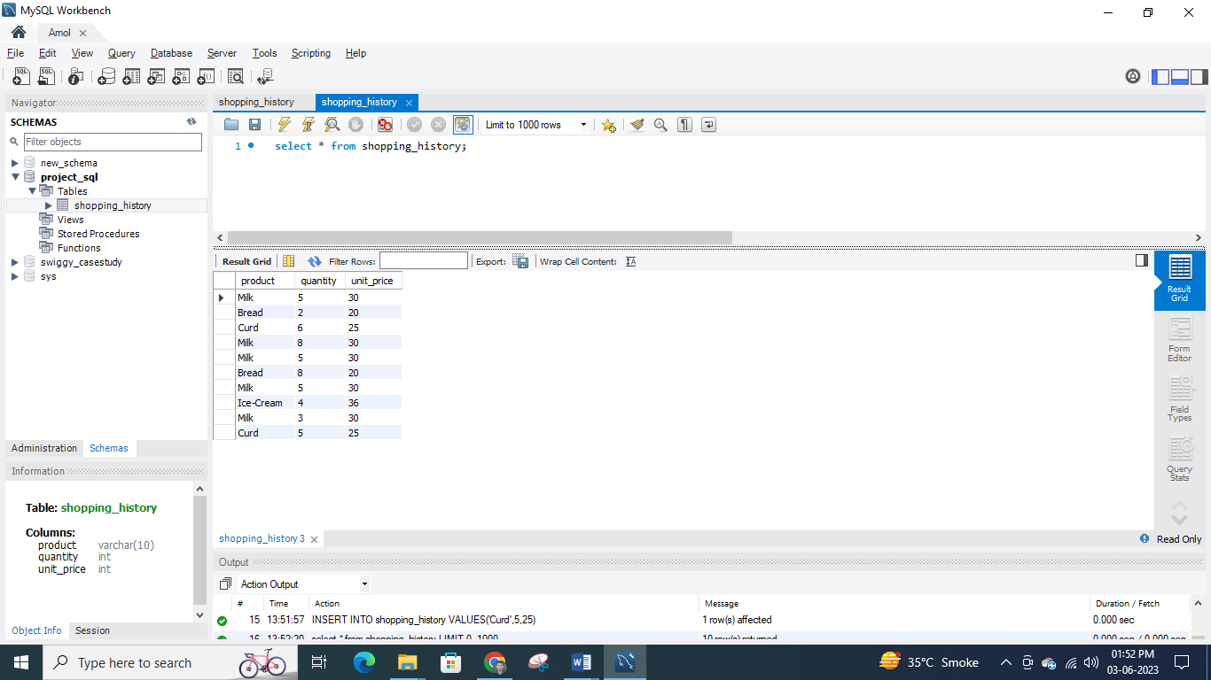 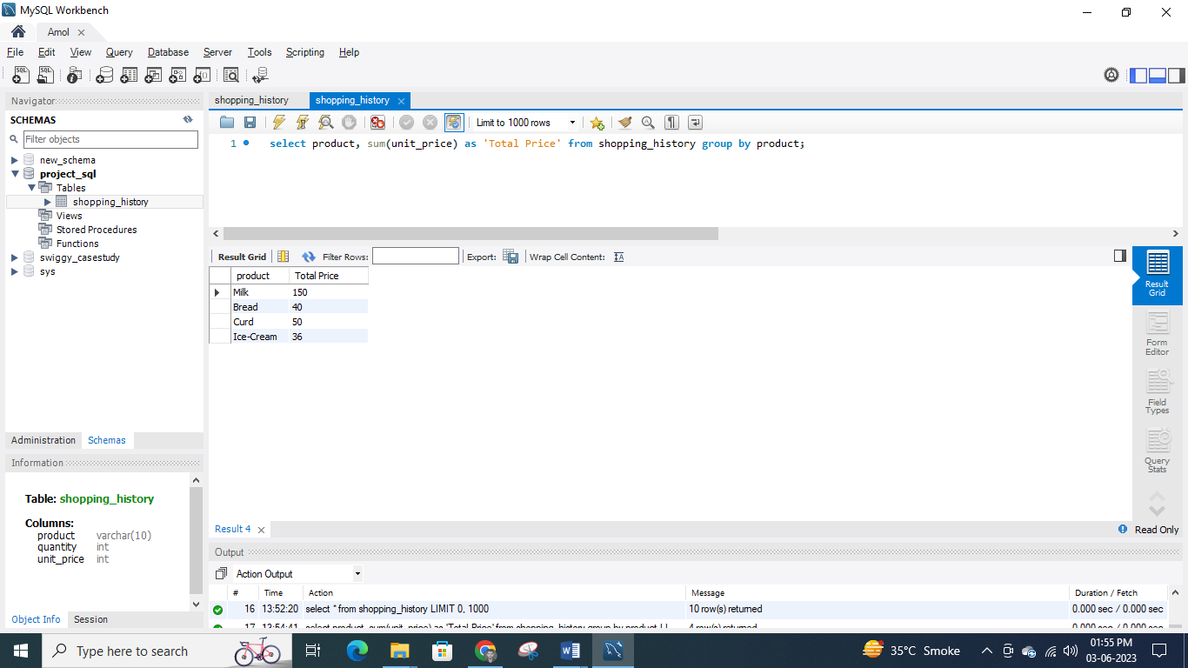

**Task 2:**

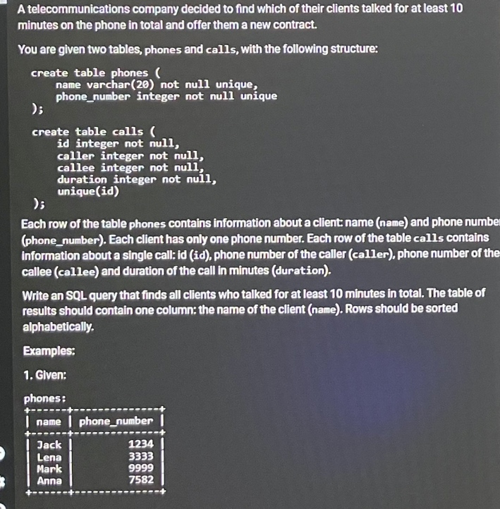 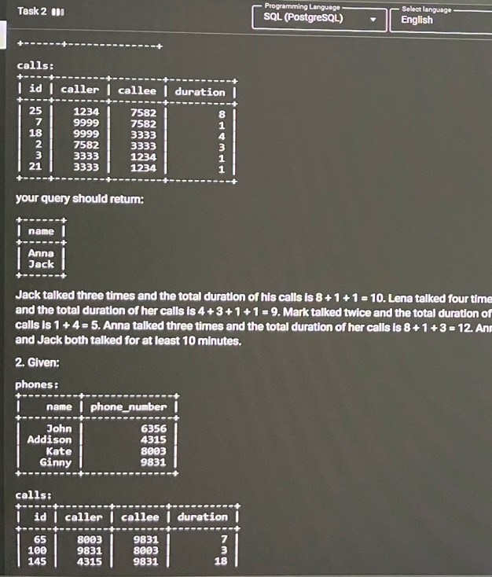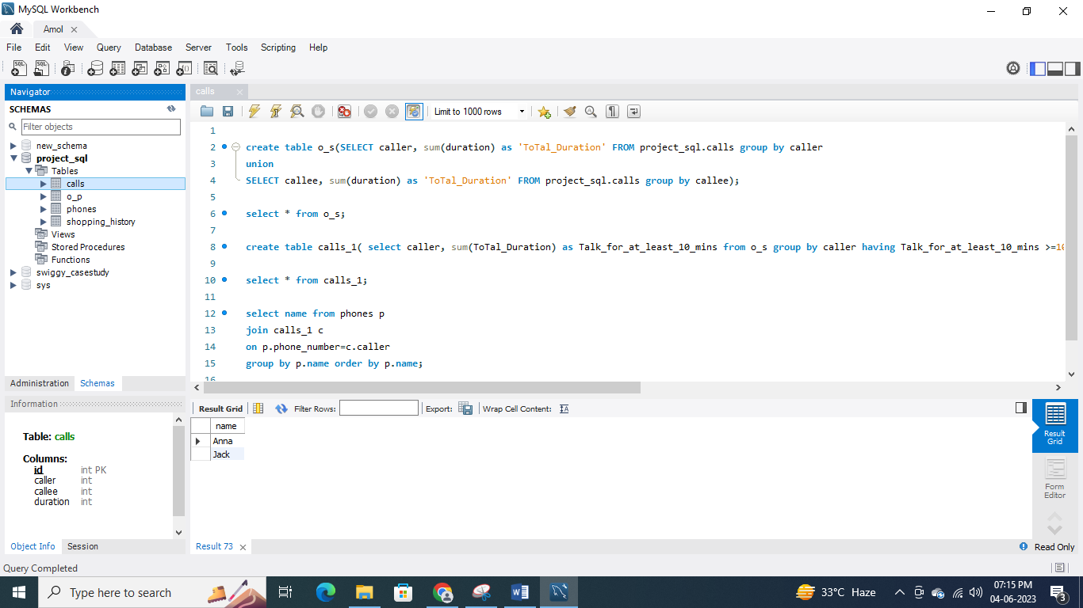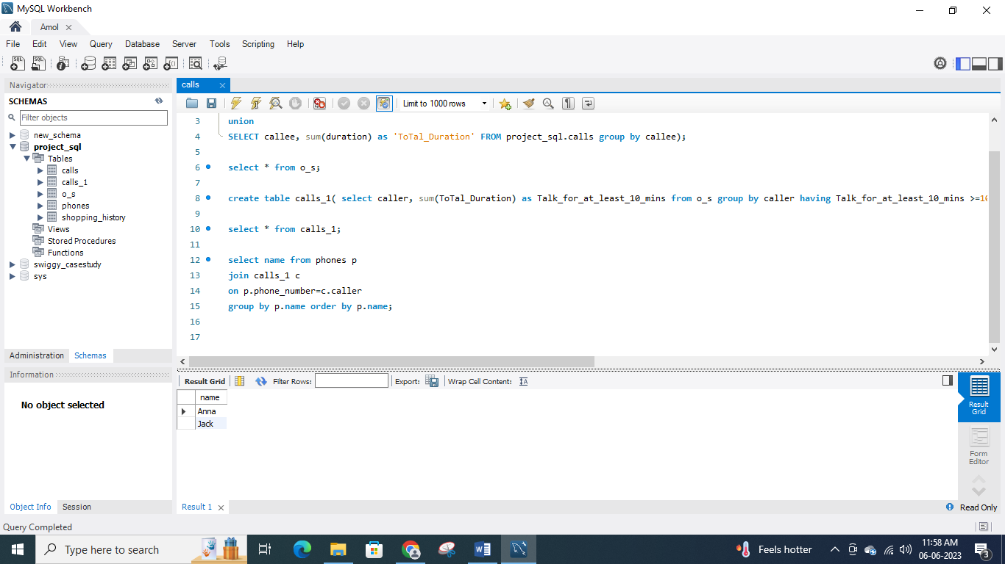

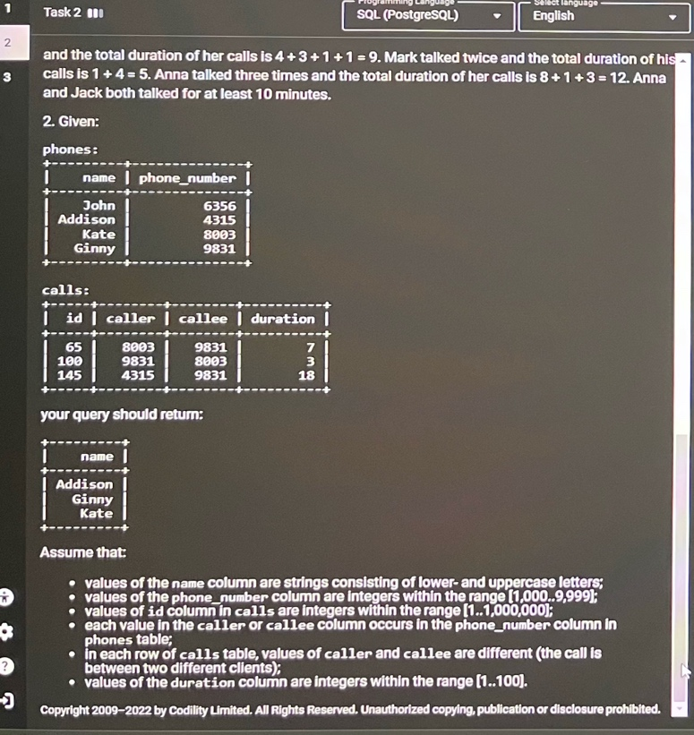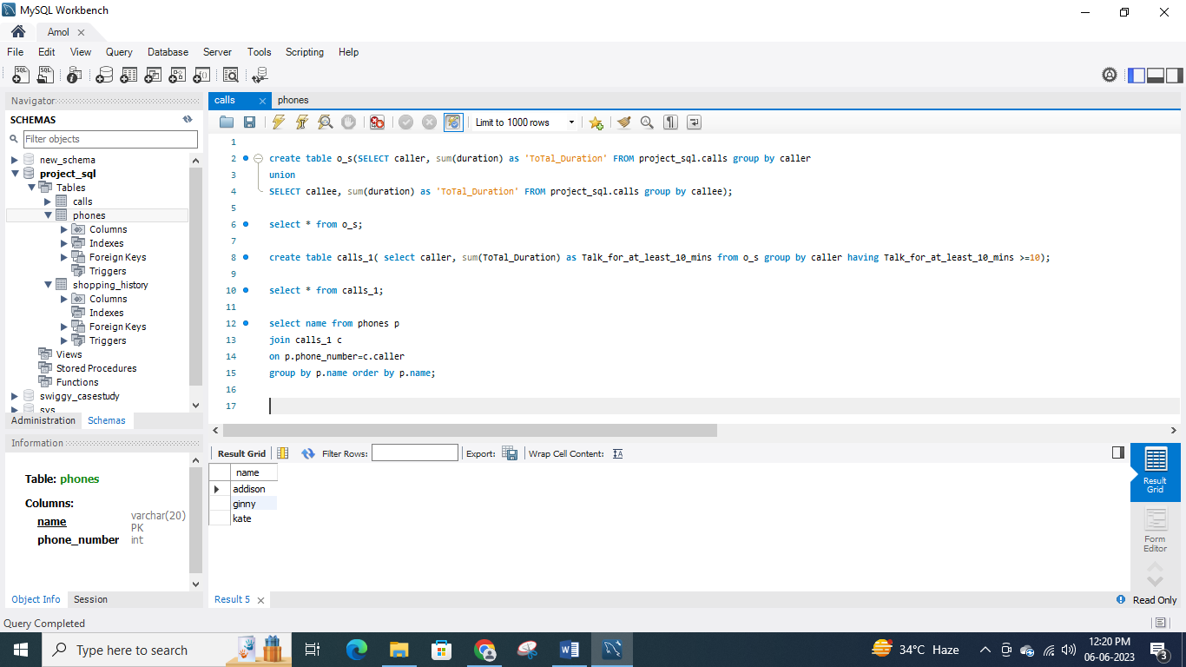

**Task 3:** **Output display is just one column balance**

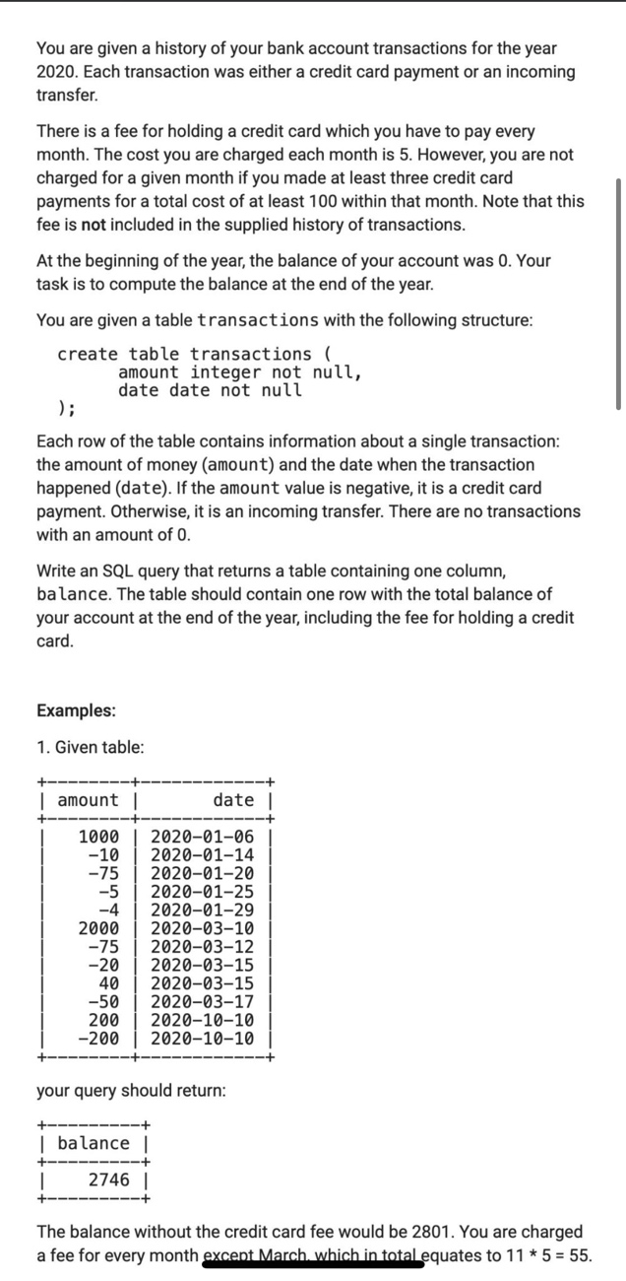 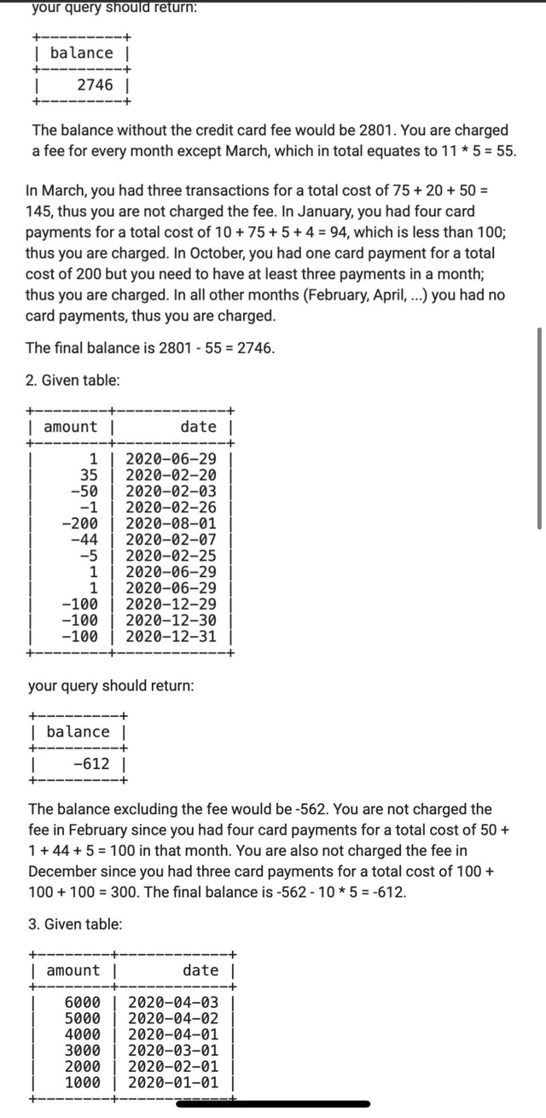

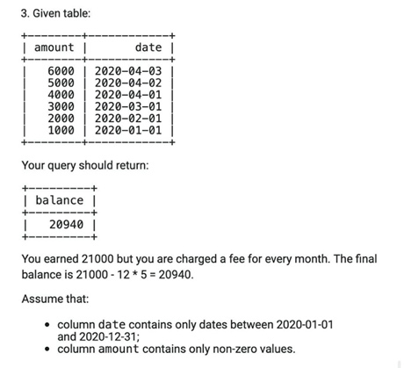

You can add the following data in the table

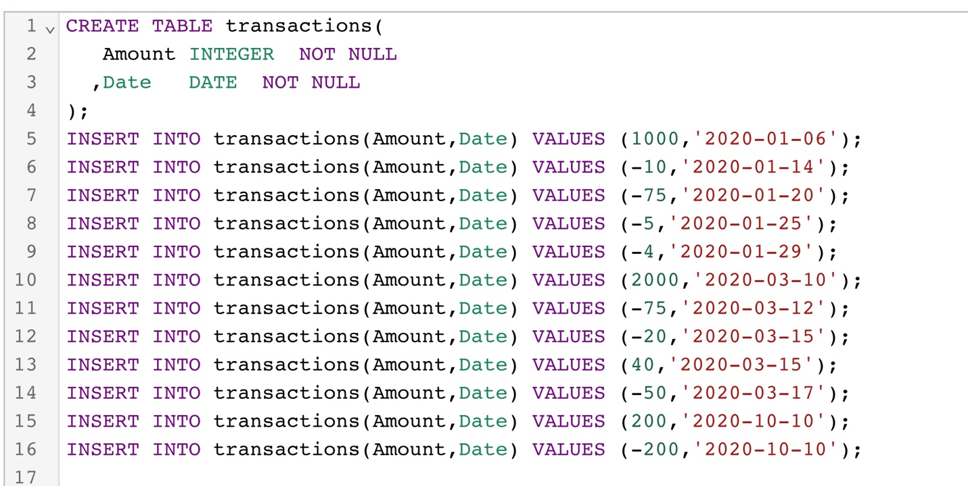

Task -1

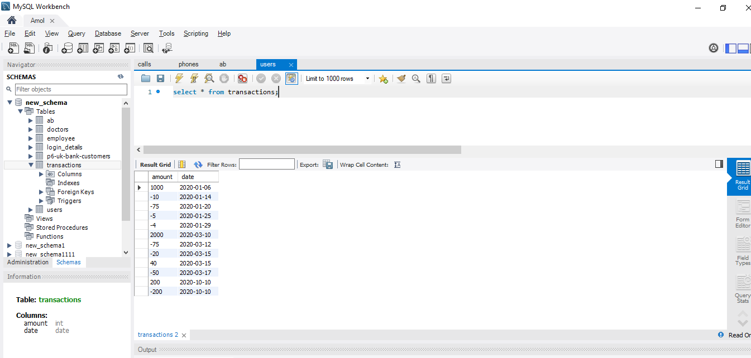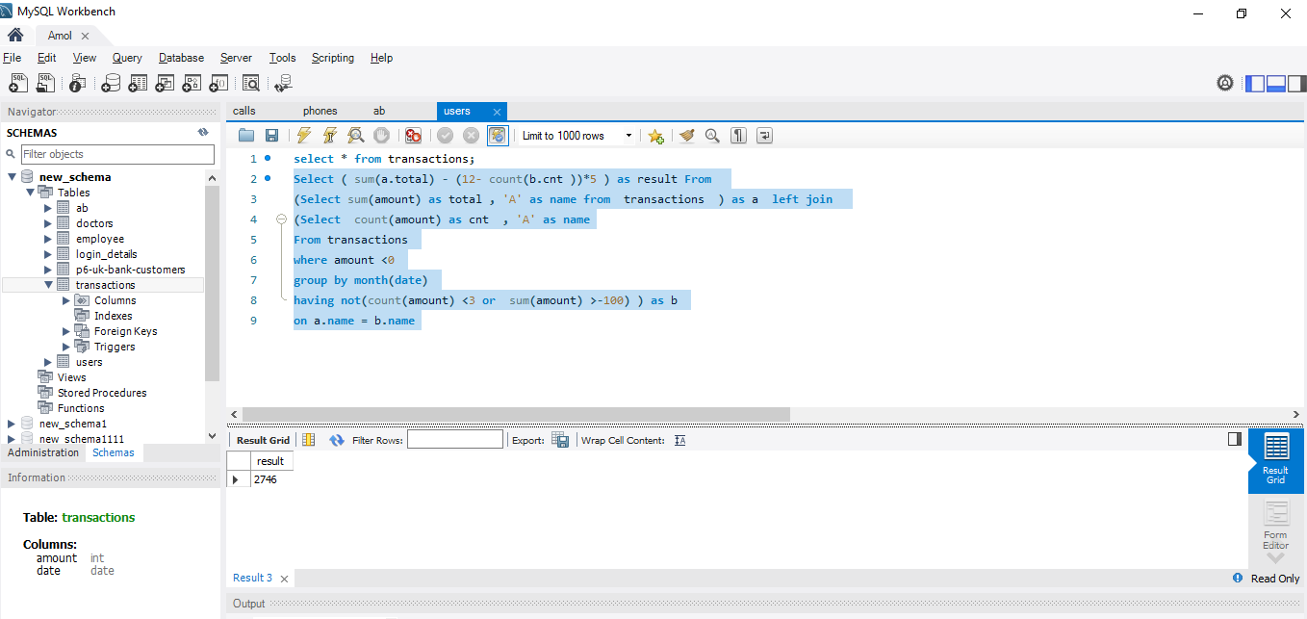

SELECT * FROM new_schema.transactions;

CREATE TABLE transactions (

Amount INTEGER NOT NULL

,Date DATE NOT NULL)

Select ( sum(a.total) - (12- count(b.cnt ))*5 ) as result From

(Select sum(amount) as total , 'A' as name from transactions ) as a left join

(Select count(amount) as cnt , 'A' as name

From transactions

where amount <0

group by month(date)

having not(count(amount) <3 or sum(amount) >-100) ) as b

on a.name = b.name

Task -2

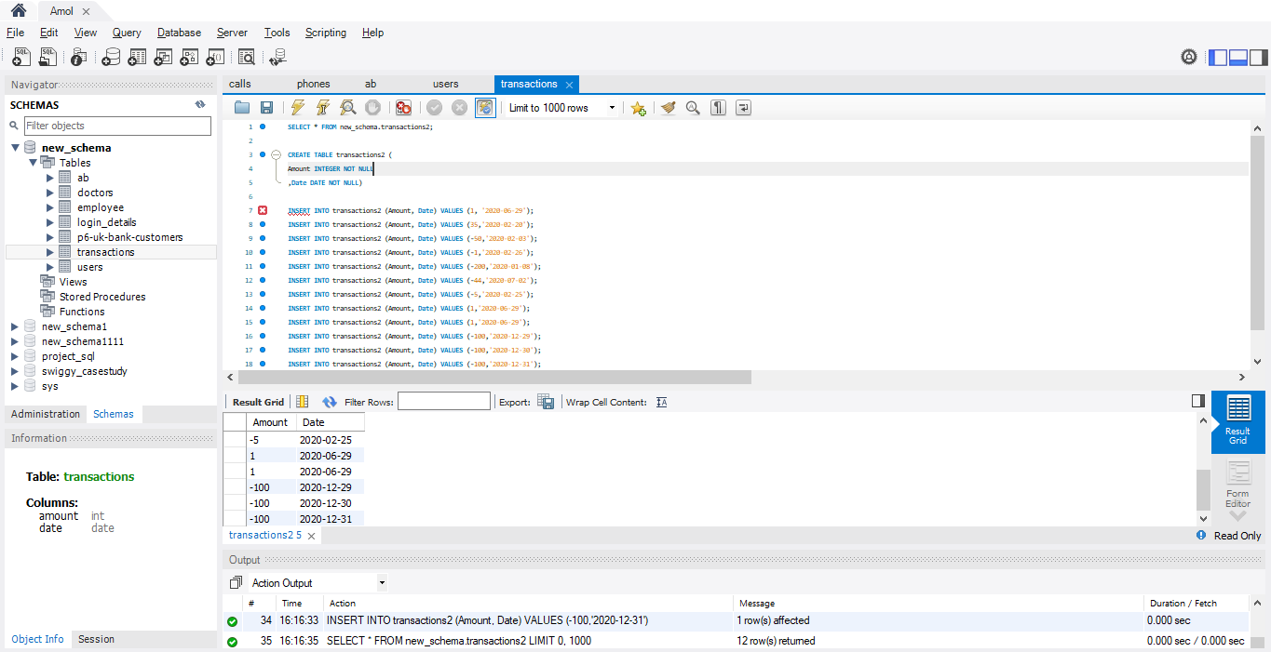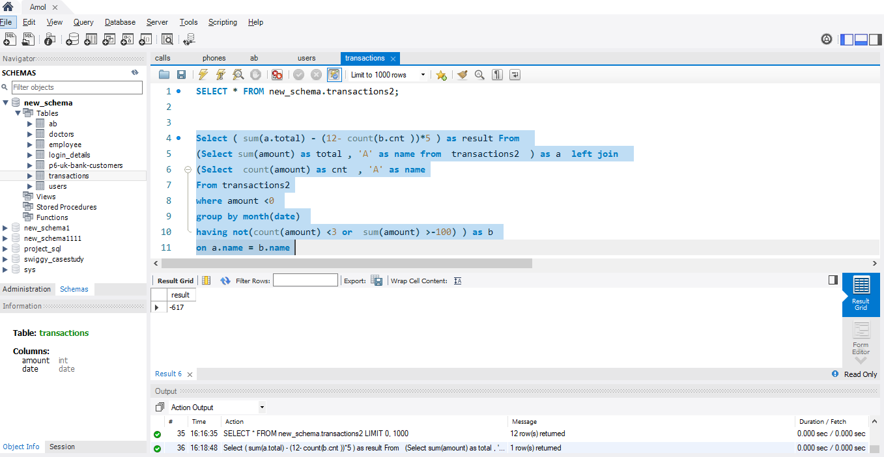

SELECT * FROM new_schema.transactions2;

CREATE TABLE transactions2 (

Amount INTEGER NOT NULL

,Date DATE NOT NULL)

INSERT INTO transactions2 (Amount, Date) VALUES (1, '2020-03-04');

INSERT INTO transactions2 (Amount, Date) VALUES (35,'2020-02-04');

INSERT INTO transactions2 (Amount, Date) VALUES (-50,'2020-01-04');

INSERT INTO transactions2 (Amount, Date) VALUES (-1,'2020-01-03');

INSERT INTO transactions2 (Amount, Date) VALUES (-200,'2020-01-02');

INSERT INTO transactions2 (Amount, Date) VALUES (-44,'2020-01-01');

INSERT INTO transactions2 (Amount, Date) VALUES (-5,'2020-03-04');

INSERT INTO transactions2 (Amount, Date) VALUES (1,'2020-02-04');

INSERT INTO transactions2 (Amount, Date) VALUES (1,'2020-01-04');

INSERT INTO transactions2 (Amount, Date) VALUES (-100,'2020-01-03');

INSERT INTO transactions2 (Amount, Date) VALUES (-100,'2020-01-02');

INSERT INTO transactions2 (Amount, Date) VALUES (-100,'2020-01-01');

Select ( sum(a.total) - (12- count(b.cnt ))*5 ) as result From

(Select sum(amount) as total , 'A' as name from transactions2 ) as a left join

(Select count(amount) as cnt , 'A' as name

From transactions2

where amount <0

group by month(date)

having not(count(amount) <3 or sum(amount) >-100) ) as b

on a.name = b.name

Task -3

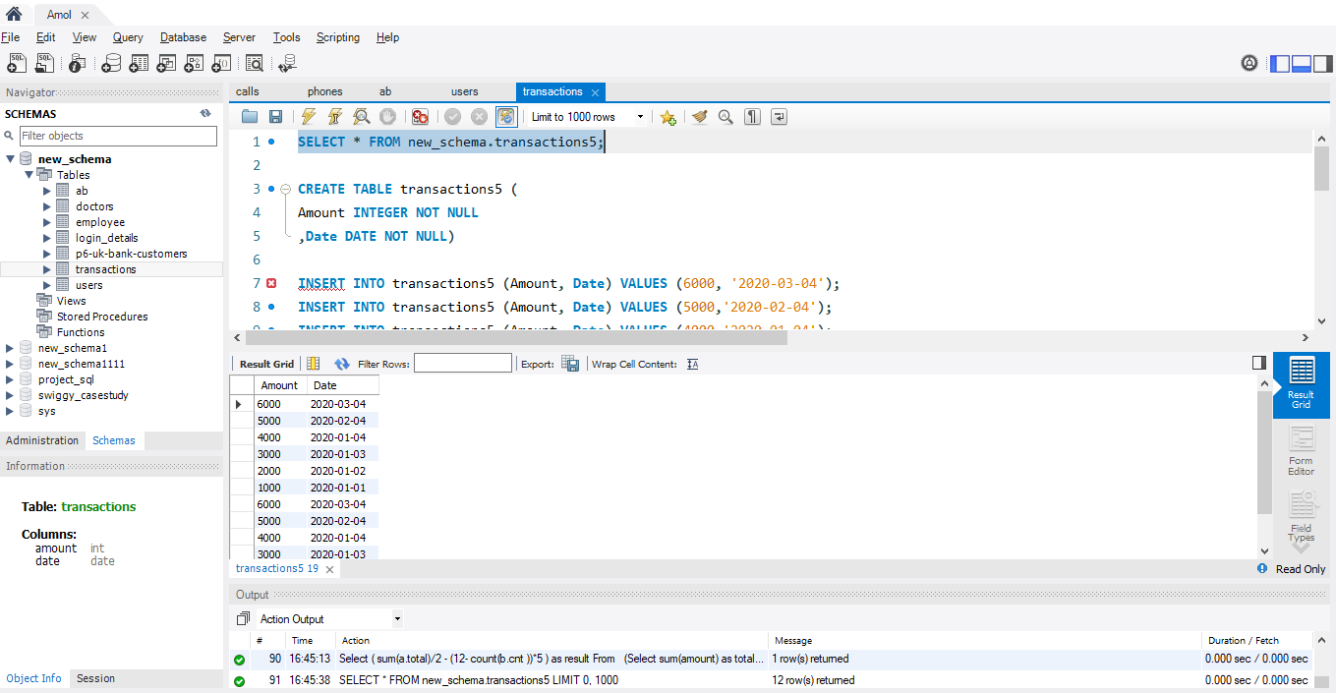 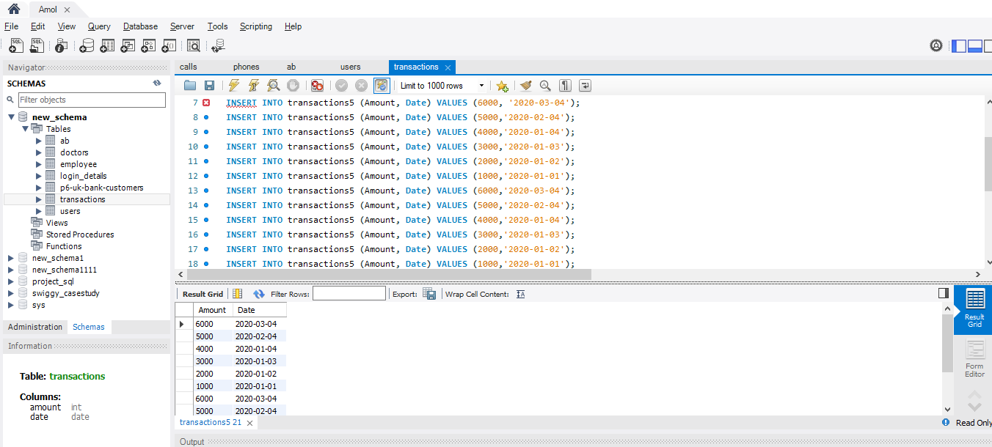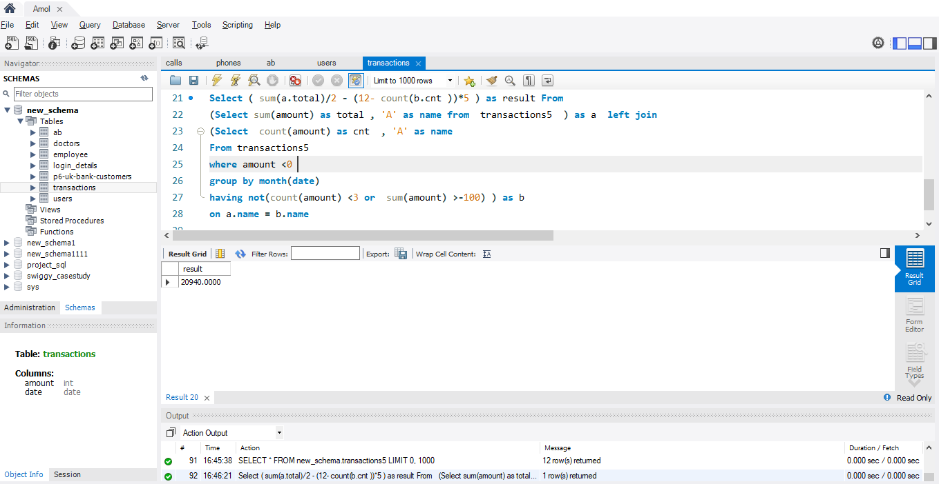

SELECT * FROM new_schema.transactions5;

CREATE TABLE transactions5 (

Amount INTEGER NOT NULL

,Date DATE NOT NULL)

INSERT INTO transactions5 (Amount, Date) VALUES (6000, '2020-03-04');

INSERT INTO transactions5 (Amount, Date) VALUES (5000,'2020-02-04');

INSERT INTO transactions5 (Amount, Date) VALUES (4000,'2020-01-04');

INSERT INTO transactions5 (Amount, Date) VALUES (3000,'2020-01-03');

INSERT INTO transactions5 (Amount, Date) VALUES (2000,'2020-01-02');

INSERT INTO transactions5 (Amount, Date) VALUES (1000,'2020-01-01');

INSERT INTO transactions5 (Amount, Date) VALUES (6000,'2020-03-04');

INSERT INTO transactions5 (Amount, Date) VALUES (5000,'2020-02-04');

INSERT INTO transactions5 (Amount, Date) VALUES (4000,'2020-01-04');

INSERT INTO transactions5 (Amount, Date) VALUES (3000,'2020-01-03');

INSERT INTO transactions5 (Amount, Date) VALUES (2000,'2020-01-02');

INSERT INTO transactions5 (Amount, Date) VALUES (1000,'2020-01-01');

Select ( sum(a.total)/2 - (12- count(b.cnt ))*5 ) as result From

(Select sum(amount) as total , 'A' as name from transactions5 ) as a left join

(Select count(amount) as cnt , 'A' as name

From transactions5

where amount <0

group by month(date)

having not(count(amount) <3 or sum(amount) >-100) ) as b

on a.name = b.name